**Formless AI replica-**

**By- Vageesh**

1. After a bit of research about formless AI, I came to know that it is an AI platform that takes form output and convinces the user to give answers.
2. So my first approach was to make a text classifier that can provide if the info is provided or not
3. So for that, I generated 20 prompts for provided and 20 for not provided which means around 240 prompts 120 and 120 for both cases.
4. For this approach, I made the dataset info given or not given
5. I made a tf-idf and random forest classifier for it.
6. The accuracy was around 90% which means this model can’t be used for our case.
7. So my next approach was to do the NER for all the different variables for which the details are provided in the file Named Entity Recognition.
8. Now I took those 20 not info provided prompts and asked chatgpt to make answer for convincing the user and made a dataset Info Not given
9. I fine-tuned llamav2-7B-4bit on this dataset and made an inference langchain on it in the notebooks titled LLM for convincing and Convincing LLM inference
10. I then combined all these operations in my final notebook titled Chat interface
11. Here there is a function that asks the user questions and then answers accordingly if the user has provided the info then it is stored otherwise LLM generates the response for user query.

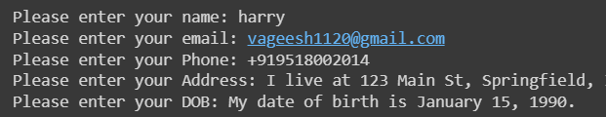

1. In case of answer is not given then the output is like this
2. Here is all the info that is getting stored in the CSV file

